Bury Hospital Discharge Pathways and Guidance

Contents
Pathway 0 2
Pathway 0 Guidance 3
Pathway 1 5
Pathway 1 Guidance 6
Pathway 2 8
Pathway 2 Guidance 9
Pathway 3 11
Pathway 3 Guidance 12
Glossary 13

Approved June 2024.

See national guidance at Hospital discharge and community support guidance

Pathway 0
Simple discharge home (to usual place of residence or temporary accommodation) coordinated by the ward without involvement of the care transfer hub, with:
- no new or additional health and/or social care and support
- self-management with signposting to services in the community
- voluntary sector support
- re-start of pre-existing home care package at the same level that remained active and on pause during the person’s hospital stay
- returning to original care home placement with care at the same level as prior to the person’s hospital stay

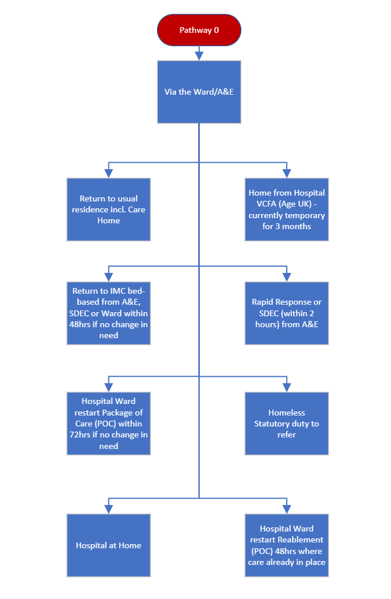

Pathway 0 Guidance
Home from hospital VCFA (Age UK)
All 50+ Bury residents with no personal care needs. Referral contact is by email homefromhospital@ageuk.Bury.Org.Uk or telephone 0161 778 3584 (Monday to Friday, 9am-5pm). This is a free service.
Responsibility for referral: Anyone/Ward

Homeless Statutory Duty to Refer
All 18+ Bury Residents who have legitimate ties to Bury and are homeless today or are at risk of being homeless in the next 56 days. Complete a Duty to refer - Bury Council
Responsibility for referral: Ward/A&E/Customer

If the person is not currently homeless or will not be homeless within 56 days, you can provide them with options to contact us:
- visiting Housing Connect and Direct between 10am and 1pm on weekdays
- emailing hat@bury.gov.uk
- calling 0161 253 5537
Homeless/rough sleepers/ABEN Rough sleepers - Bury Council
No care and support needs. All 18+ bury resident People can also self-present to Housing and do not need to remain in hospital if they have no care and support needs.

ABEN A bed every night - A bed every night - Bury has made a commitment to provide 'a bed every night' (ABEN) for all people that are sleeping rough on the streets in Bury. Our ABEN service will provide:
- a bed every night for referred rough sleepers.
- accommodation with appropriate facilities, 24 hours a day.
- intensive support for customers. Referrals can be completed via the link at the top or bottom of the page. However, please be aware that customers will only be contacted when a vacancy is available. If a customer is rough sleeping and requires contact from our outreach team, please contact roughsleepers@bury.gov.uk with details. Online referrals to the ABEN service are not appropriate for families with dependent children, instead please use our homeless assessment service.

Responsibility for referral: Ward/A&E/Customer

Staying well - Bury Council
Anyone over the age of 50 who is not in receipt of/ do not need services now but would benefit from a discussion regarding future care and support and how to access services example people discharged pathway 0 but would benefit from support for health and wellbeing.
Criteria:
- You are over 50 years of age and;
- You are registered with a GP in the borough
- You live within the borough
- You are not in receipt of adult care support
This is a free service.
Responsibility for referral: Ward/A&E

Rapid Response Service
All 18+ bury resident. 2-hour response. The Rapid Response Service is provided by a multi-disciplinary team of health and social care staff. The focus is on preventing avoidable admission to acute hospital or residential care. Referrals into the service are received from health or social care professionals and the team will respond within two hours of an appropriate referral to undertake assessment. Telephone referral via 0161 253 6292.
NB: Hospital at Home - Supporting early discharge from wards. Frailty (+65), Respiratory and General Med wards active. Soon to add Heart Failure. Consultant oversight required – please discuss with Fiona Cowie or Tania Scott.
Responsibility for referral: A&E /MAU/SDEC/Consultants

Pathway 1
Discharge home (to usual place of residence or temporary accommodation) with health and/or social care and support coordinated by the care transfer hub, including:
- home-based intermediate care on a time-limited, short-term basis for rehabilitation, reablement and recovery at home
- re-start of home care package at the same level as a pre-existing package that lapsed
- returning to original care home placement with time-limited, short-term intermediate care
- long-term care and support at home following a period of intermediate care in the community

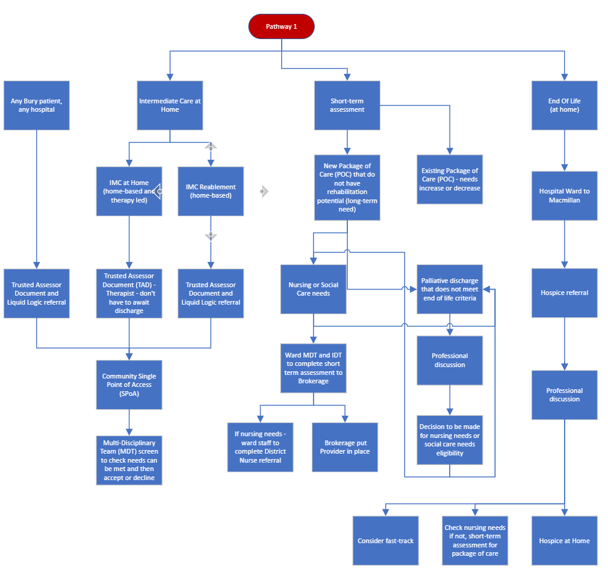

Pathway 1 Guidance
Intermediate Care Therapy At Home
All 18+ people who have clear therapy only goals and do not require reablement and packages of care referred to the single point of access hospitalswteam@bury.gov.uk for IMC therapy at home this is free up to the point of review for longer term needs by our IMC team.
Criteria:
- 18+
- Able to engage in therapy
- Have goals
They cannot support unstable fractures/nursing tasks but referrals to d/c cannot be serious mental health which impedes engagement. Please note that people can be referred for reablement and IMC Therapy at home on the same document.
Responsibility for referral: Trusted assessment to single point of access therapy for goals /IDT for assessment

Reablement
All 18+ people who are not known to have care in place prior to hospital and have not had a life changing event but have care and support needs should be assessed and referred to the single point of access hospitalswteam@bury.gov.uk for reablement services – this is free up to the point of review for longer term needs by our IMC team.
Criteria:
- 18+
- Able to engage in reablement
- Have goals
They cannot support unstable fractures/nursing tasks but referrals to d/c can be used alongside serious mental health which impedes reablement.
Responsibility for referral: Trusted assessment to single point of access therapy for goals /IDT for assessment

Restart of packages of care within 72 hours of admission
If you have someone in hospital who already has a commissioned package of care and can be discharged without any change in the plan and have been in hospital less than 72 hours
Wards may contact the care provider directly or contact our brokerage team to support Monday to Friday only on 0161 253 3583/3773/3590/3773. Commissioned care provider contacts.
This is a chargeable service as pre-hospital admission.
Responsibility for referral: Wards/Customers

Restart or increase/change in commissioned packages of care
If you have someone in hospital who already has a commissioned package of care and has been in hospital more than 72 hours this person requires assessment.
How to refer – send trusted assessment to SPoA or commissioned care provider contacts.
This is a chargeable service.

NB: Consideration may be given to Rapid Response bridging the gap to commencement of a commissioned package (incl. a specified time period) if there is capacity within the team.

Fast-track CHC
If someone is in their last days of life, is rapidly deteriorating and requires a package of support at home they may be eligible for Fast-track CHC funding. Initial contact to be made with the Hospital Discharge team for assessment.
CHC team will require the following documentation:
- Completed fast-track document by a Nurse/Dr involved in the individual's care
- Completed consent form
- Completed care plan detailing what care is needed etc.

CHC service operates Monday to Friday 09:00 to 17:00.

Responsibility for referral: Integrated Discharge Team - 0161 778 3582.

Pathway 2
Discharge co-ordinated through the care transfer hub to a community bedded setting with dedicated health and/or social care and support, including bed-based intermediate care on a time-limited, short-term basis for rehabilitation, reablement and recovery in a community bedded setting (bed in care home, community hospital or other bed-based rehabilitation facility).

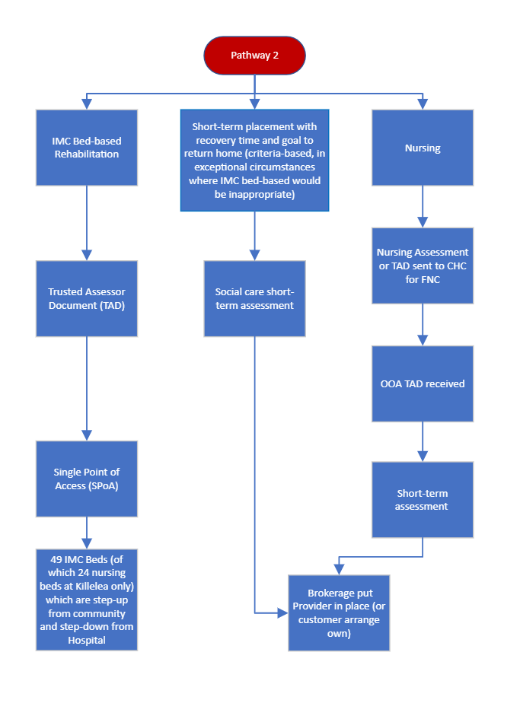

Pathway 2 Guidance

IMC Bed-based rehabilitation
Intermediate care (IC) is a non-means-tested, time-limited, short-term support provided by the NHS and social care services. Its goal is to help individuals avoid unnecessary hospital admissions and promote independence. Here are the key points:
Responsibility for referral: Therapy trusted assessment to single point of access

Have been assessed by a member of the Multi-Disciplinary Team as having the potential to benefit from a period of targeted rehabilitation aimed at maximising their potential for independent living.

That there is the potential for the service user to increase his / her present level of physical function and independence. This should be able to be achieved within a specified time frame not requiring long-term involvement.

Be prepared to work towards a set of agreed goals aimed at maximising their potential for independent living. Goals tend to be physical, cognitive, perceptual, social and occupational with an emphasis is on functional goals.

Rehabilitation potential cannot be met at home at this stage.

To support timely discharge from the hospital.

All 18+ who have been assessed for home first IMC and reablement and screen out of home-based services and require rehabilitation with the expectation that people will be able to be discharged home on completion of the IMC rehab.

Support needs should be assessed and referred to the single point of access hospitalswteam@bury.gov.uk for IMC bed- based services – this is free up to the point of review for longer term needs by our IMC team and will be screened in an MDT – if the IMC team feel needs can be met at home they will ask for assessment to be amended.

Criteria:
- 18+
- Able to engage in reablement
- Have goals
- Are safe to be left alone in a room
- Are able to use a call bell
- Must not have unstable fractures or serious mental health condition which impedes reablement. NB: These patients may require a short-term placement with funding which will be supported if appropriate by the IMC Therapy Team. In these exceptional cases, individual discussions between the IDT and IMC management will take place to establish the most appropriate onward destination. Agreement must be made as to where the decision is recorded and who will undertake the review.
FNC assessment
Where an assessment indicates that the person has nursing needs, and the interim care act assessment indicates that the person’s needs are best met in a care home with nursing then the funded nursing care contribution will be awarded without prejudice and formal assessment for the FNCC comes later.
On discharge from hospital the Integrated Discharge team will notify the FNC/CHC team and following discharge from hospital and within 4 weeks the FNC/CHC team will complete a full nursing assessment for funded nursing care which will include screening for CHC using the checklist.
Responsibility for referral: Integrated Discharge Team.

CHC assessment
CHC checklists/assessments should not be completed in an acute hospital setting as it gives an inaccurate reflection of long-term needs. This will be completed post discharge:
· Discharge home or in Residential Care at first review by SW/Community Nurse if needed.
· Discharge to Care Home with Nursing – by CHC team at 4 weeks.

Pathway 3
In rare circumstances, for those with the highest level of complex needs, discharge to a care home placement co-ordinated through the care transfer hub, including:
- care home placement for assessment of long-term or ongoing needs and facilitation of patient choice in relation to the permanent placement.
- long-term care and support in a care home following a period of intermediate care in the community.

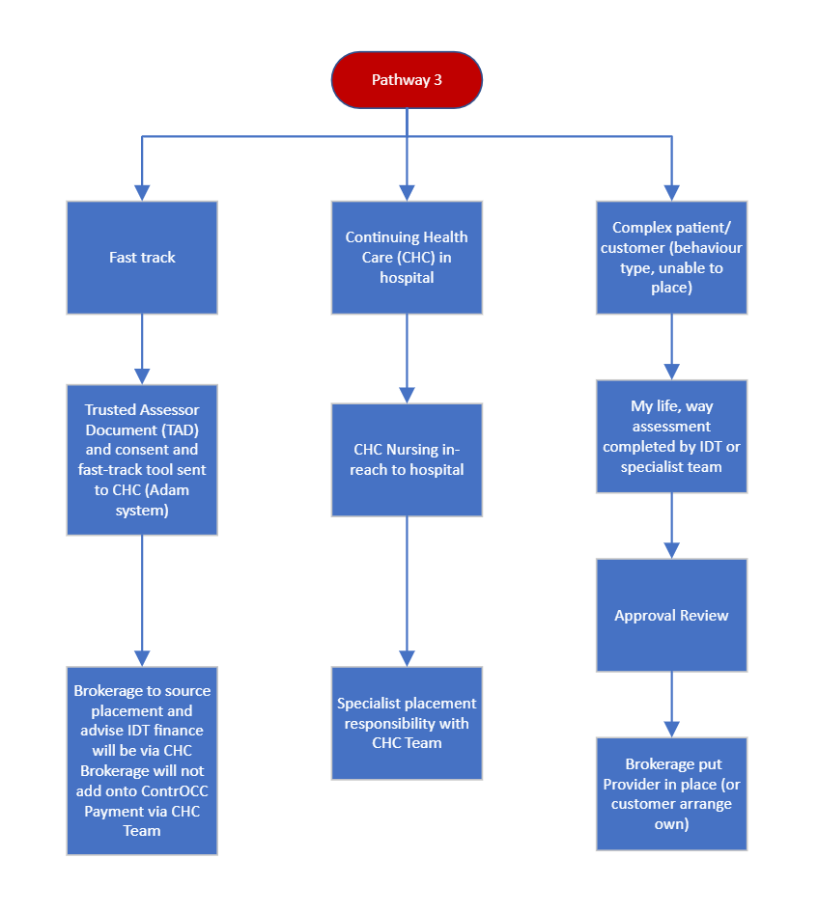

Pathway 3 Guidance

Complex Care/Fast Track

All 18+ who have been assessed as likely to need longer term care on leaving hospital support needs should be assessed and referred to the single point of access (SPoA) there must be a significant life changing event that cannot be rehabilitated, and long-term needs must be clearly established.

Add to PTL list and advise that this requires a Bury social worker or a complex care on site can complete the assessment.

These individuals will either be assessed under the LA funding without prejudice, CHC or LA/FNC funding without prejudice.

Please note that where any 1:1 or significant mental health/behaviours are identified these people will need supplementary evidence such as ABC, Behaviour Charts and Mental Health reports as required.
Please note for any CHC/Fast Track consent and assessment will be required.

Responsibility for referral: Bury social work or transfer of care nurse/Bury social worker for complex social care and IDT nurse for nursing trusted assessment to CHC with consent and nursing assessment.

Glossary

ABC - Antecedent Behaviour Consequence
CHC – Continuing Health Care
FNC – Funded Nursing Care
IDT – Integrated Discharge Team
LOS – Length of Stay
MAU - Medical Admissions Unit
MDT – Multi-Disciplinary Team
OOA – Out Of Area
PTL - Patient Tracking List
SDEC - Same Day Emergency Care
TAD- Trusted Assessor Document

